TASK 1 – Data Import & Cleaning using Power Query
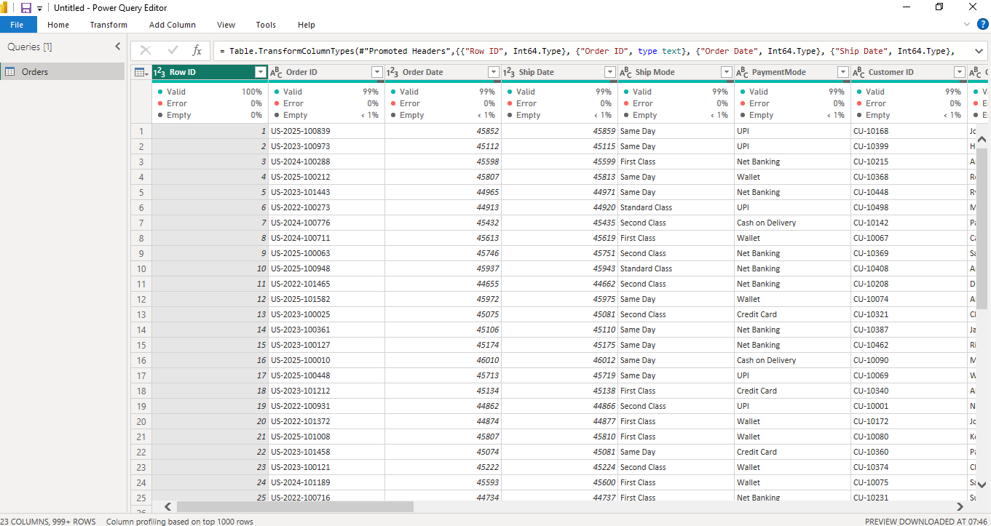

1. Imported the Excel dataset into Power BI Desktop using Home → Get Data → Excel Workbook and opened it in Power Query Editor.
2. Removed duplicate records using the 'Remove Duplicates' option to ensure each record was unique.
3. Checked every column for missing (null) values using Column Quality and Column Distribution.
4. Handled missing values appropriately by removing unnecessary null rows or replacing missing values where required.
5. Verified and corrected the data type of every column (Date, Text, Whole Number and Decimal Number).
6. Split the 'Customer Name' column into two separate columns: 'First Name' and 'Last Name' using Split Column → By Delimiter (Space).
7. Renamed the generated columns to business-friendly names such as 'First Name' and 'Last Name'.
8. Renamed additional columns where appropriate (e.g., PaymentMode → Payment Mode, Returned → Return Status).
9. Reviewed the cleaned dataset to ensure there were no duplicate records, incorrect data types, or unwanted null values.
10. Clicked 'Close & Apply' to load the cleaned data into the Power BI data model.
After cleaning:
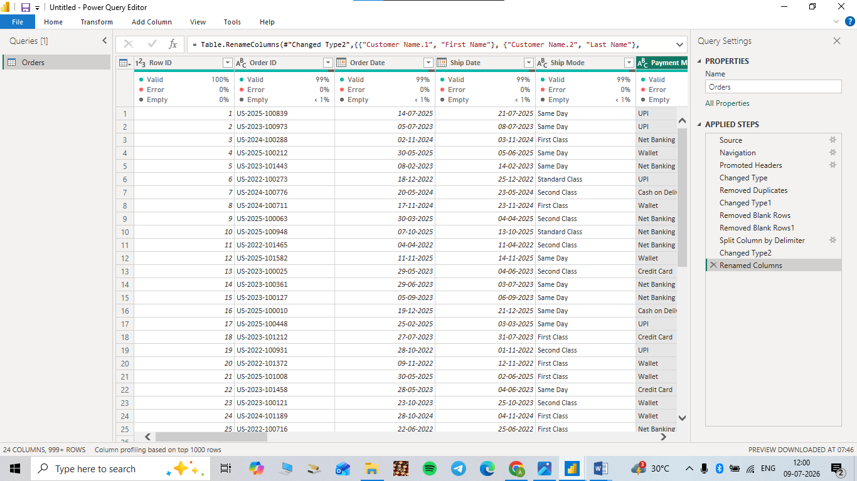

TASK 2 – Data Modeling

- Used the imported Orders table as the Fact Table because it contains transactional sales data.
- Created a Customer Dimension table (DimCustomer) containing Customer ID, First Name, Last Name and Segment.
- Created a Product Dimension table (DimProduct) containing Product ID, Product Name, Category and Sub-Category.
- Created a Location Dimension table (DimLocation) containing Country, Region, State and City.
- Created a Date Table using the DAX CALENDAR() function based on the minimum and maximum Order Date.
- Marked the Date Table as the official Date Table.
- Created one-to-many relationships between the Fact table and each Dimension table using the appropriate key columns.
- Set the Cross Filter Direction of all relationships to Single.
- Arranged the tables in Model View to form a Star Schema with Orders at the centre and all Dimension tables surrounding it.
Creation of tables using dax
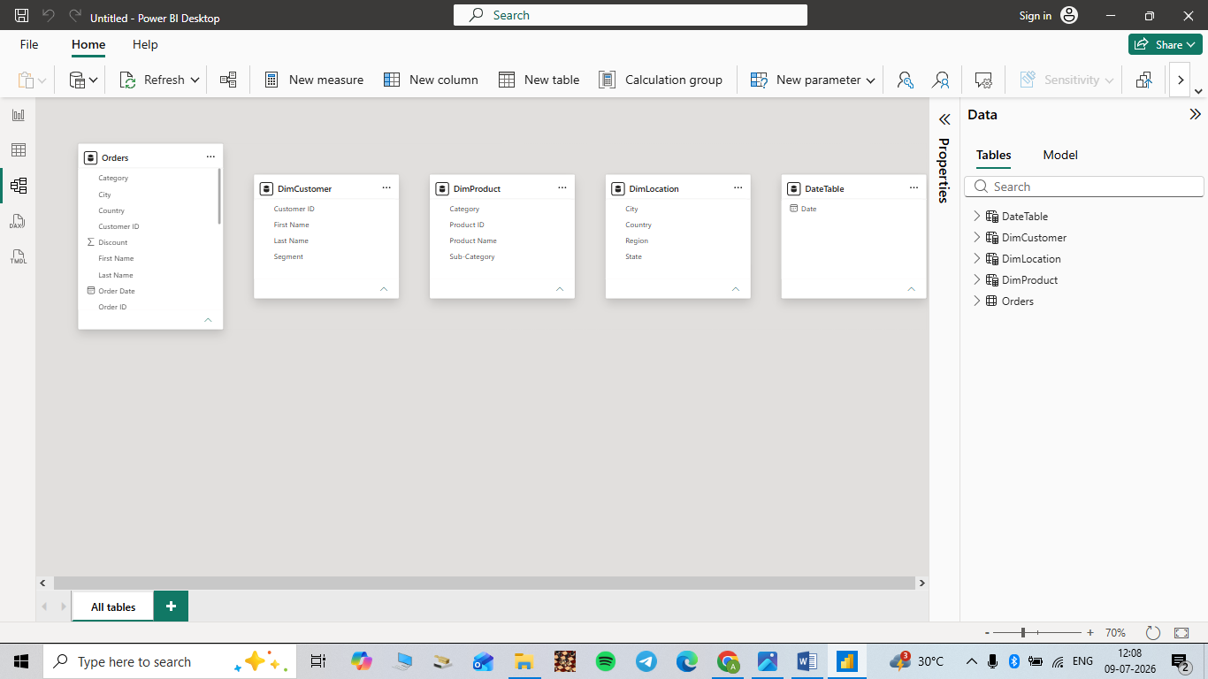

TASK 3 – DAX: Calculated Columns & KPI Measures

Created the following KPI measures using aggregation functions:
• Total Sales = SUM(Orders[Sales])
• Total Profit = SUM(Orders[Profit])
• Total Orders = COUNT(Orders[Order ID])
• Total Customers = DISTINCTCOUNT(Orders[Customer ID])
• Average Sales = AVERAGE(Orders[Sales])

Task 4: Interactive Sales Dashboard Design
